**University of Michigan – Dearborn**

**Department of Computer and Information Science**

**CIS 150L – Fall 2014**

Lab 4

Srinivas Simhan

10/06/14

**Table of Content**

1. Question 1 3
   1. Screenshots 3
   2. Source Code 3
2. Question 2 4
   1. Screenshots 4
   2. Source Code 4
3. Question 3 5
   1. Screenshots 5
   2. Source Code 5
4. **Question 1**
   1. **Screenshot**

10 & 20:

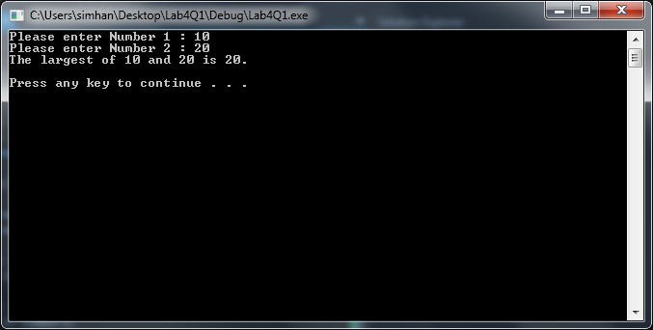

20 & 10:

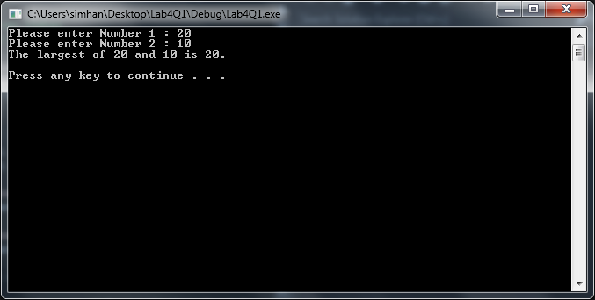

* 1. **Source Code**

//Larger Number

//Author: Srinivas Simhan

//Creation Date: 9/29/2014

#include <iostream>

#include <string>

using namespace std;

int main()

{

int number1;

int number2;

cout << "Please enter Number 1 : ";

cin >> number1;

cout << "Please enter Number 2 : ";

cin >> number2;

if (number1 > number2)

{

cout << "The largest of " << number1 << " and " << number2 << " is " << number1 << "." << endl << endl;

}

else if (number1 < number2)

{

cout << "The largest of " << number1 << " and " << number2 << " is " << number2 << "." << endl << endl; }

else if (number1 == number2)

{

cout << "Try Again." << endl << endl;

}

system("pause");

return 0;

}

1. **Question 2**
   1. **Screenshots**

Integer: 0

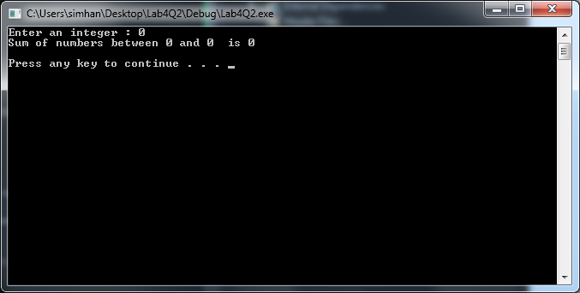

Integer: 3

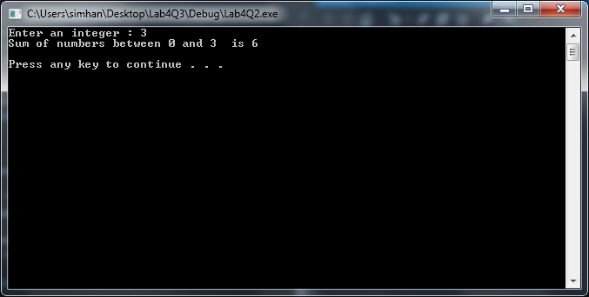

Integer: 7

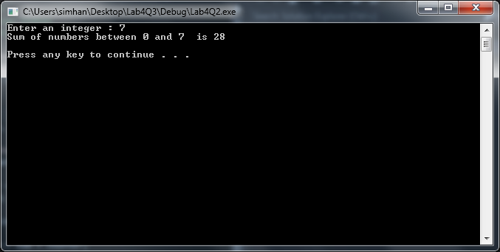

Integer: 9

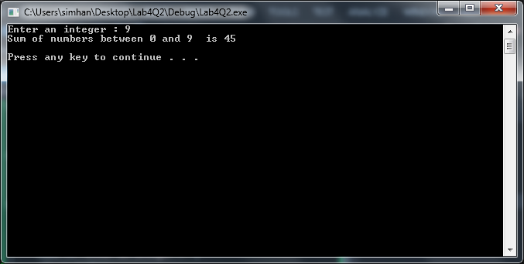

* 1. **Source Code**

//Number Counter

//Author: Srinivas Simhan

// Creation Date: 10/06/14

#include <iostream>

#include <string>

using namespace std;

int main()

{

int counter, sum, number;

cout << "Enter an integer : ";

cin >> number;

counter = 0;

sum = 0;

while (counter <= number)

{

sum = sum + counter;

counter++;

}

cout << "Sum of numbers between 0 and " << number << " is " << sum << endl << endl;

system("pause");

return 0;

}

1. **Question 3**
   1. **Screenshots**

if (students != 0):

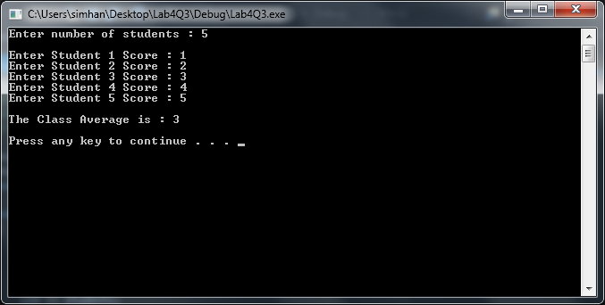

else if (students == 0):

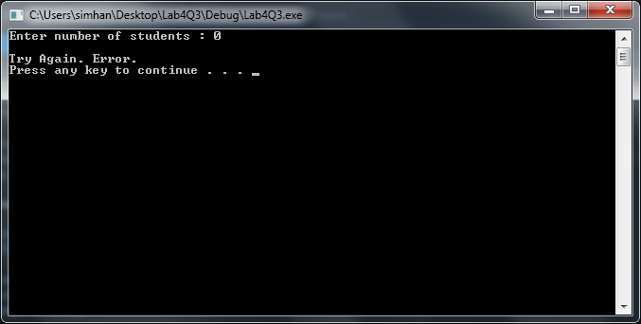

* 1. **Source Code**

//Class Averager

//Author: Srinivas Simhan

// Creation Date: 10/06/14

#include <iostream>

#include <string>

using namespace std;

int main()

{

int counter = 1, students;

float total = 0, average;

cout << "Enter number of students : ";

cin >> students;

cout << endl;

if (students != 0)

{

for (float score; counter <= students; counter++)

{

cout << "Enter Student " << counter << " Score : ";

cin >> score;

total = total + score;

}

cout << endl;

average = total / students;

cout << "The Class Average is : " << average << endl << endl;

}

else if (students == 0)

{

cout << "Try Again. Error." << endl;

}

system("pause");

return 0;

}